Procedure Guide for testing

DoJa TEST CONTENTS (BASIC)

Version 1.1

Dec, 9, 2002
NTT DoCoMo, Inc.

Document History
Ver. | Chapter | Type | Description
1.0 |  |  | First edition release
1.1 | Fig.1  Fig.2 | added | Added Localized items.

1. Introduction
This book describes an examination procedure required in order to use Doja1.5 test contents.

2. Using the Testing Contents
This chapter explains an example of the usage of Doja1.5 examination contents.

About actual test management, since the operating flow by the test implementation user (Operator) is planned, it considers as the outside of the object of this book.

This book has described only the work procedure about test implementation.

In addition, in order to examine, examination environment needs to be set up. Refer to the environmental setting procedure document for installation of examination environment.

2.1 Structure
Doja1.5 examination contents consist of the following materials per item.

- Test item table
- Testing procedure manual
- Test content (including java sources)

The Doja1.5 examination contents currently offered are as follows.
Job_No | Name | Description | Notes
J01 | API TEST | The check of behavior of API defined by the API reference
J02 | ADF TEST | The test about operation of an ADF parameter.
J11 | MEDIA TEST | The test of Supported Media of operation
J21 | CLASS TEST | The test which mainly verifies the contents of the clarification Specifications.
J22 | JAM-JVM TEST | The test about the verification of JAM and JVM
J31 | Communication (HTTP) TEST | The test which checks in communication operation paying attention to the communication  Class API of HTTP.
J33 | Communication(ScratchPad) TEST | The test which checks in communication operation paying attention to the communication class API of ScratchPad.
J34 | Communication (Resource)  TEST | The test which checks in communication operation paying attention to the communication class API of Resources.
J35 | Communication (Simultaneous  multiplex) TEST | The test which uses API of a communication class mutually
J42 | Interruption TEST | The interruption operation test of normal application.
L | Localized TEST | The test using the characteristic characters in each country. (Except ASCII characters)
Table.1 DoJa1.5 TEST CONTENT LIST

2.2 Testing flow
The worker who examines assumes examining by the flow of the following figure.
Figure.1 TESTING FLOW

2.3 The contents of the test items document
The test item document is offered by the file of Microsoft Excel2000 form. The Excel file consists of sheets of the Job Number unit, and the experimental series is classified and expressed for every sheet.
(Since the API test has many items, it is dividing the file into three.)

The test item table to offer is as follows.
Job No. | File Name | Category | Notes
J01 | J01_TEST_ITEM(io_lang_net).xls | Normal Route
J01 | J01_TEST_ITEM(ui).xls | Boundary Route
J01 | J01)_TEST_ITEM(util).xls | Loop Test
J01 |  | Abnormal Route
J02 | J02_TEST_ITEM(ADF).xls | Normal Route
J02 | J02_TEST_ITEM(ADF).xls | Boundary Route
J02 | J02_TEST_ITEM(ADF).xls | Loop Test
J02 | J02_TEST_ITEM(ADF).xls | Abnormal Route
J11 | J11_TEST_ITEM(media).xls | Normal Route
J11 | J11_TEST_ITEM(media).xls | Boundary Route
J11 | J11_TEST_ITEM(media).xls | Combination
J11 | J11_TEST_ITEM(media).xls | Error Route
J21 | J21_TEST_ITEM(Class).xls | Class
J21 | J21_TEST_ITEM(Class).xls | UI Boundary
J21 | J21_TEST_ITEM(Class).xls | UI Combination
J22 | J22_TEST_ITEM(JAM-JVM).xls | JAM-JVM behavior
J22 | J22_TEST_ITEM(JAM-JVM).xls | Dialog competition
J31 | J31_TEST_ITEM(Com-HTTP).xls | Basic Operations
J31 | J31_TEST_ITEM(Com-HTTP).xls | Boundary Operations
J31 | J31_TEST_ITEM(Com-HTTP).xls | Repeating Operations
J33 | J33_TEST_ITEM(Com-Spad).xls | Basic Operations
J33 | J33_TEST_ITEM(Com-Spad).xls | Boundary Operations
J33 | J33_TEST_ITEM(Com-Spad).xls | Repeating Operations
J34 | J34_TEST_ITEM(Com-Resource).xls | Basic Operations
J34 | J34_TEST_ITEM(Com-Resource).xls | Boundary Operations
J34 | J34_TEST_ITEM(Com-Resource).xls | Repeating Operations
J35 | J35_TEST_ITEM(Com-Sync).xls | Basic Operation
J42 | J43_TEST_ITEM(Interrupt).xls | Java in Execution
J42 | J43_TEST_ITEM(Interrupt).xls | Other function being executed
J42 | J43_TEST_ITEM(Interrupt).xls | Variations of Interruptions
L | Localized_TEST_ITEMS | Europe (West)
L | Localized_TEST_ITEMS | Chinese(Traditional)
L | Localized_TEST_ITEMS | Chinese(Simplified)
Table2. TEST ITEMS TABLE LIST

The example of a screen of a test item table (Ms-Excel) is as follows.
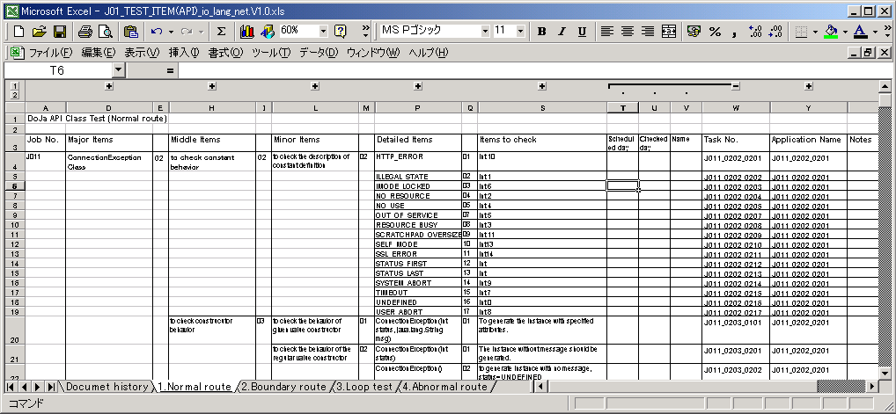
TEST Category
Major Items
Middle Items
Minor Items
Items to check
Task No.
Application Name
Job No.
Notes
Scheduled day
Checked day
Name
Detailed Items

Figure2. Test Items Table sample image

The explanation of each item of an examination item document is as follows.
Name | Description
Job No. | This field is the Job Number (J01-J42).
Category | This field is the series of a test.
Major Items,  Middle Items,  Minor Items,  Detailed Items (Conditions) | This field describes the item which subdivided the experimental contents.
Items to check | This field has described the contents checked by the examination item.
Scheduled date | This field fills in the scheduled day which tests.
Checked date | This field fills in the day when the tester examined.
Name | This field fills in the name of the tester which tests.
Notes | This field has described notes, such as notes when examining, and an examination with enforcement unnecessary in addition to this.
Task No. | They are the consecutive numbers of an examination item.  The consecutive numbers are issued under the following rules.  J011_0101_0101  Items to check  Minor Items  Middle Items  Major Items  Category  Job Number
Application Name | Application File Name
Table.3 Explanation of each field in an examination item document

2.4 The contents of the testing procedure manual
The test procedure document is offered by the file of XML form. The XSL processor is required to refer to, or the HTML conversion by the browser which can refer to XML.

・Recommendation browser
Microsoft Internet Explorer 6.0(for Windows)

The XML file of an examination procedure document is in the directory of the same name as an application name, as shown below.

ApplicationName.xml
The examination procedure document is stored in the folder of an application name. As for the XML file of a procedure document, only one file exists in one directory.

Explanation of the contents
Content description
- The testing procedure document has described all test items that can carry out the application in one procedure document (XML file).

2. Task Number is assigned to each test items and one of the test task number corresponds to one test task number
of a test item document.
3. In each examination, when there are many operation items, the operation procedure in application also increases.

The example of a screen of an examination procedure document is described to Fig. 3.
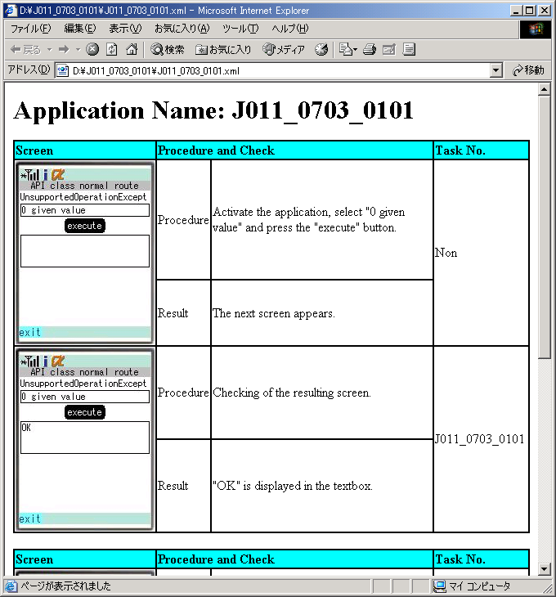
This is one test unit. One examination item is completed after finishing the procedure to a task number
Procedure and a result are 1 set.
Figure.3 Testing Procedure Manual Sample image.

＊ The meaning is as follows when the screen image of the following figure exists in a procedure, the meaning is as follows.
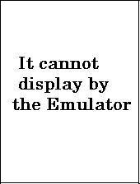 | 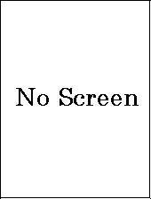
Although the behavior as specification is O.K., the above-mentioned screen displays it by Emulator of Doja1.5, when behavior to expect is not performed. (Screen for which emulator operation is improper) | The above-mentioned screen shows  operation of the function which is not mounted in DoJa1.5 Emulator. (e.g. Display message of the native dialog of a handset etc.)
Figure.4
About expression and its meaning in case the screen of a procedure document differs from a handset.
(Screen for which emulator operation is improper)

The explanation of each item of a procedure document is as follows.
Name | Description
Application Name | This item is the application name of test content.
Screen | It is the screen before operating it.  When performing two or more operations, the result of the last operation is shown after the 2nd screen.
Procedure | It is the procedure of test operation.
Result | They are the contents of a check of a test item.
Task No | The test item which is carrying out the current test is expressed.
Table.4 Explanation of each field in an examination procedure document

